ANZAM Mixed Methods Research SIG
Report 2022 & Plan 2023
Co-Conveners:
Prof Roslyn Cameron  Director of Centre for Organisational Change and Agility (COCA),  Torrens University Australia  Adelaide  Email: ros.cameron@torrens.edu.au  Dr Matthew Xerri  Senior Lecturer  Griffith Business School  Griffith University  Email: m.xerri@griffith.edu.au | Dr Farveh Farivar  Senior Lecturer  School of Business and Economics  University of Tasmania  Email: farveh.farivah@utas.edu.au  Em. Prof Anneke Fitzgerald (ANZAM Life Member)  Griffith University & Adjunct with Torrens University Australia  Email: anneke.fitzgerald@griffith.edu.au  Note A/Prof Bob Cavana has retired
2022 Activities – Summary
Due to COVID-19 and associated restrictions/lock downs/border closures/illness since April 2020 and into 2021/22 the ANZAM MMR SIG has been considerably less active as in previous years.
The ANZAM SIG was first established in 2011, twelve years ago at the ANZAM Conference in Hobart 2011.
Foundational Co-founders:
- Dr Ros Cameron
- Prof. Ray Cooksey (ANZAM Life Member)
- Prof Anneke Fitzgerald

- 1. Mixed Methods International Research Association (MMIRA) https://mmira.wildapricot.org/
Ros Cameron was an Executive Board member of the Mixed Methods International Research Association (MMIRA) from 2018- 2022 and currently Committee member of the MMIRA-Oceania Chapter of the MMIRA.
2. Editor of Edward Elgar Handbook of MMR in Business & Management
2021-2022 saw a lot of time consumed by the Editing of the Edward Elgar Handbook of Mixed Methods Research in Business and Management and many MMR SIG members writing chapters for the Handbook.
Professor Ros Cameron and Dr Xanthe Golenko are (co-editors of Handbook) which is due for release October 2023.
Members who have co-authored/authored chapters include:
Anneke Fitzgerald
Ros Cameron
Xanthe Golenko
Matt Xerri
Ryan Gould
Farveh Farivar
Heinz Herrmann
Shankar Sankaran
International Advisory Committee for the Handbook:
- Professor Jose Molina-Azorin, University of Alicante, Spain and Editor of JMMR (Q1 ranked)
- Professor Judith Schoonenboon, University of Vienna, Austria
- Em. Professor Anneke Fitzgerald, Griffith University
- Professor Pat Bazeley, UWS and TUA
- Dr Aharon Factor, SCU
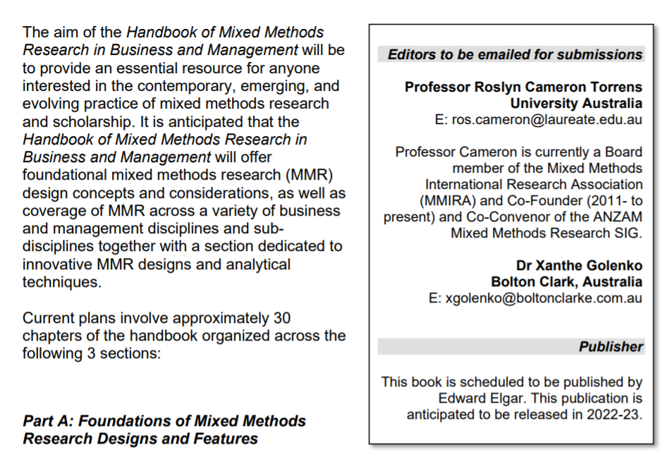
https://www.e-elgar.com/shop/gbp/handbook-of-mixed-methods-research-in-business-and-management-9781800887947.html

- MMR SIG Workshop at ANZAM Conference 2022:
Members of the MMR presented a MMR Workshop at the 2022 ANZAM Conference:
Workshop Title: Mixed Methods Research (MMR) in Business and Management
Presenters included:
- Ros Cameron
- Xanthe Golenko
- Heinz Herrmann
- Farveh Farivar

The Workshop was well attended and its was great to be back F2F.

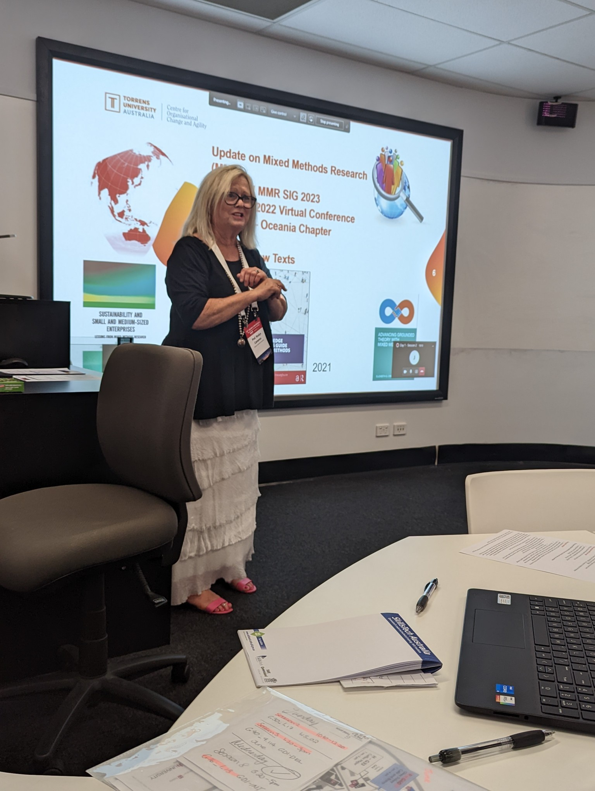 | 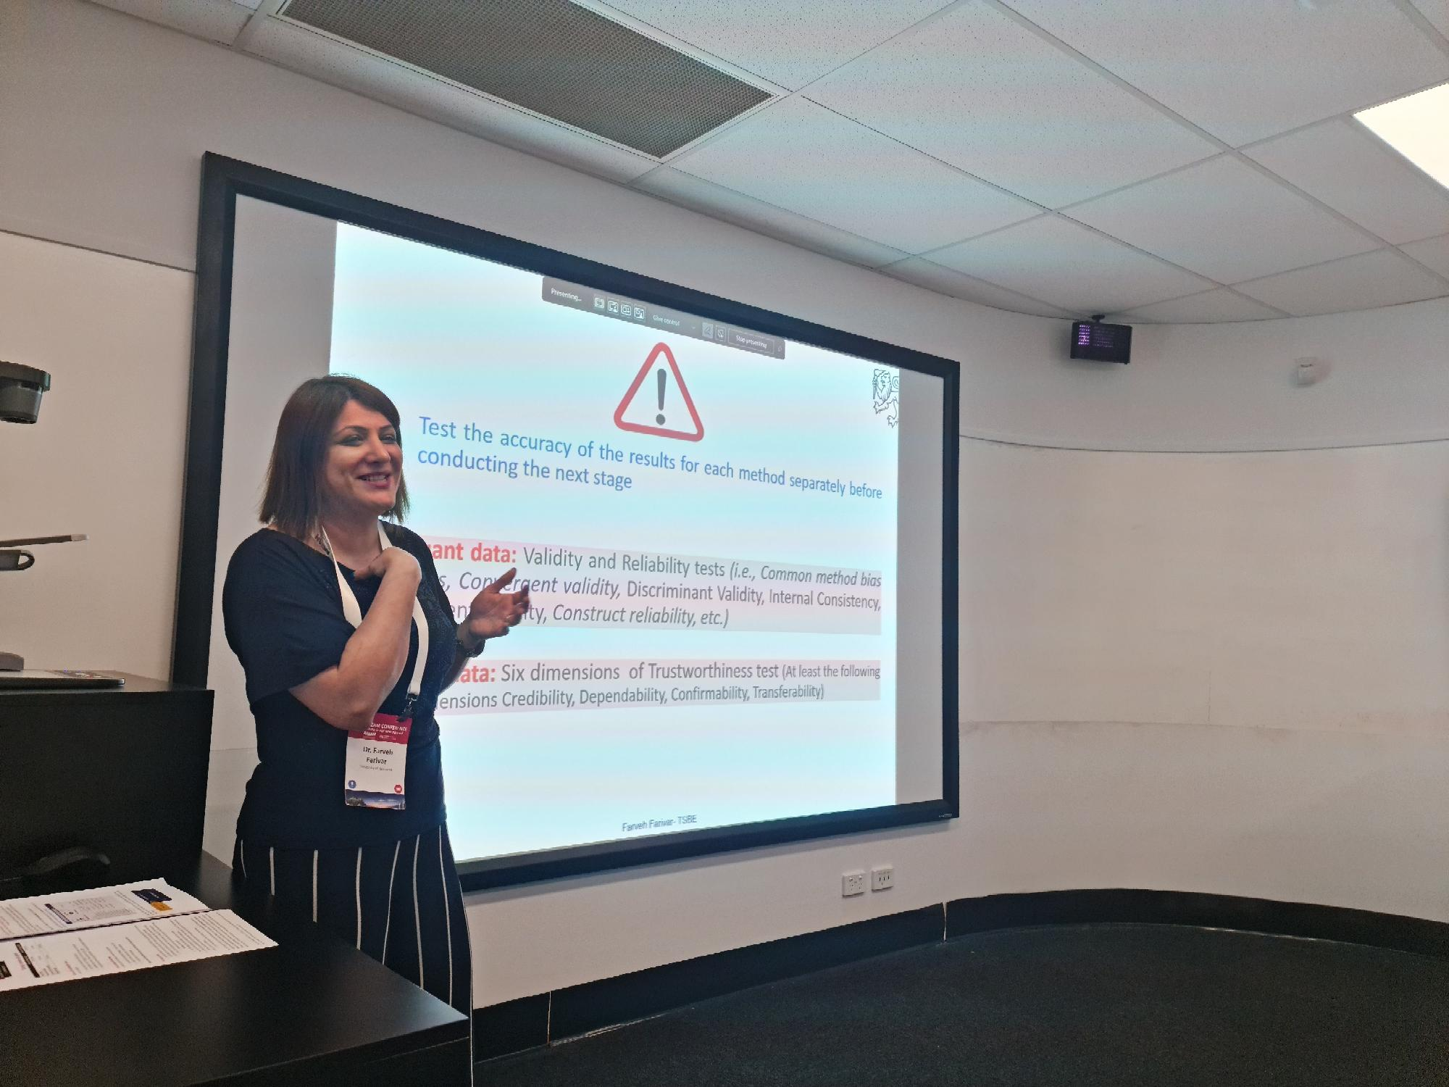
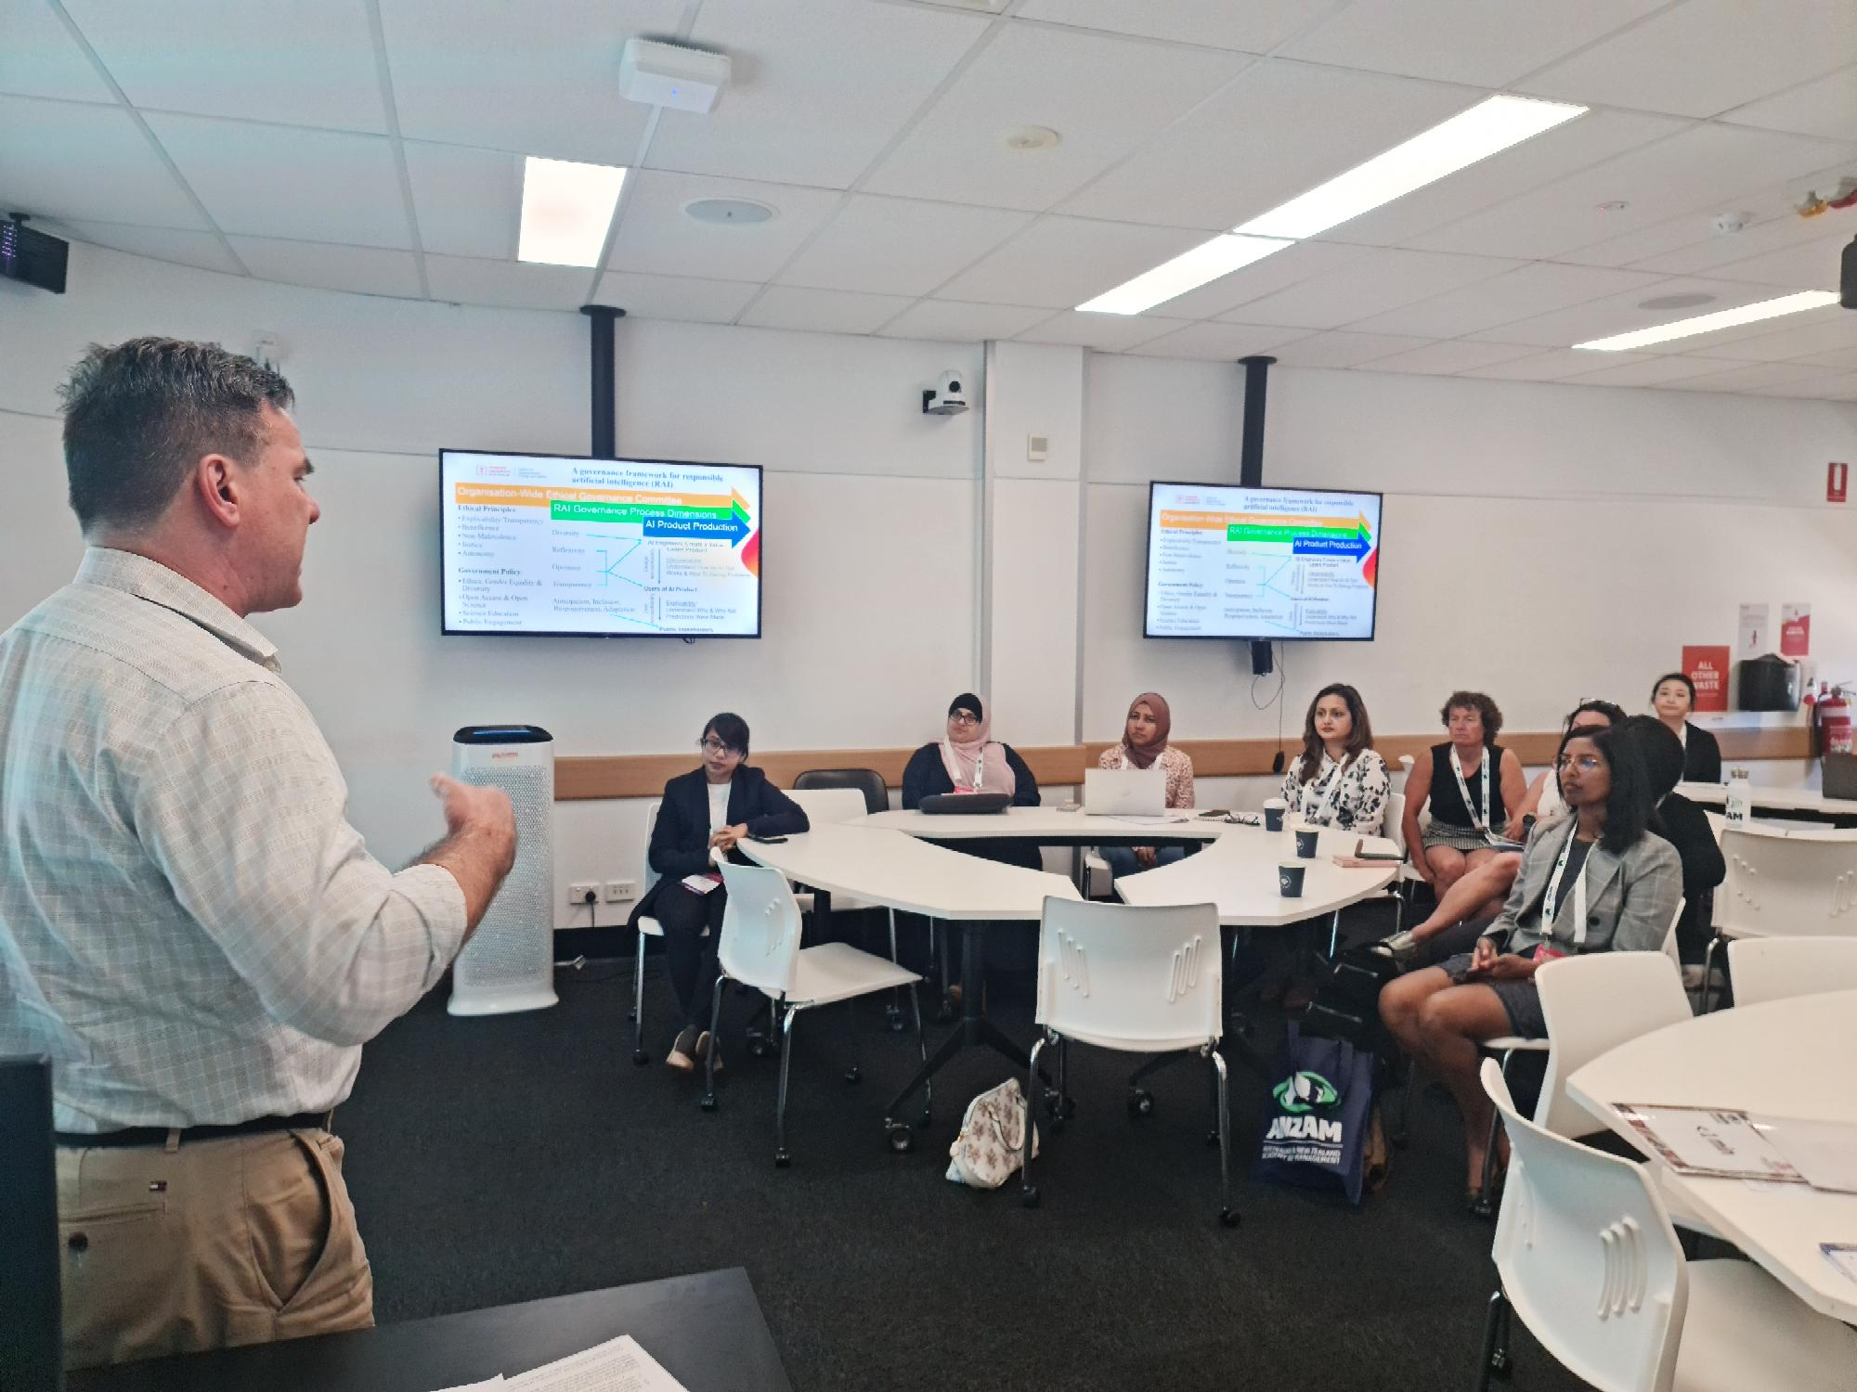 | 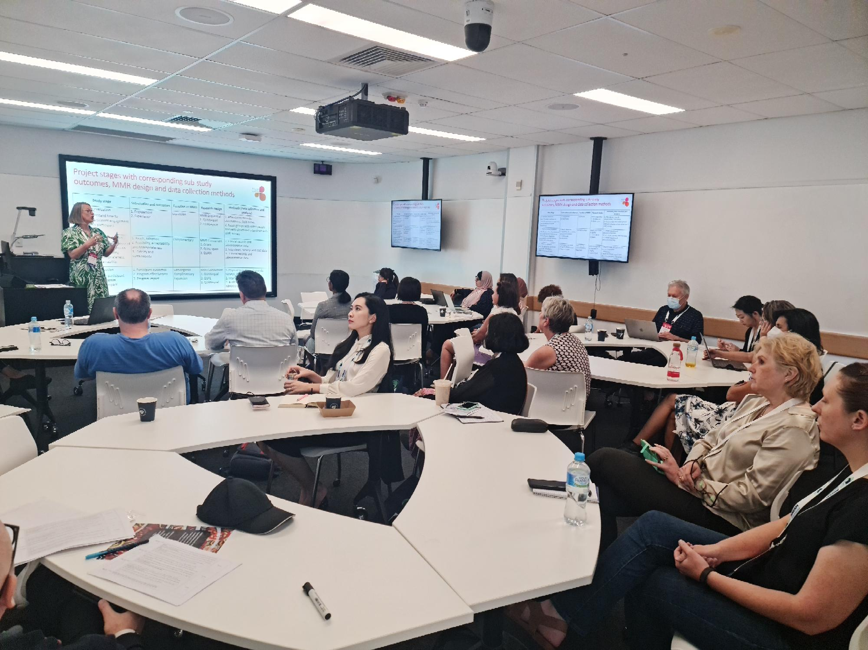

PLAN 2023

- Regional Mixed Methods Workshop
The Conveners will decide on a regional Workshop to take place sometime in the second half of 2023 which will depend on Conveners’ availability to travel.

Past Workshops have been conducted at Griffith Uni/ Gold Coast (QLD), Adelaide (SA), Perth (WA), Wollongong, Sydney (NSW) and Hobart (TAS).

Melbourne would be an obvious choice.
REQUEST FOR FUNDS: The SIG will need to request a Budget for travel and accommodation to conduct the Workshop and seek a Melbourne based Business School to host the event (possibly RMIT).
TBA
APPROX $2,000 - $3,000 depending on location of presenters/conveners’

- Launch of Edward Elgar Handbook of Mixed Methods Research in Business and Management

This will be hosted and sponsored by Torrens University Australia as an online event in early November with all ANZAM members invited.

- Submit a Proposal for a Special Issue of JMO to the JMO Editorial team

MMR SIG Conveners to submit to JMO in November 2023.

- MMR SIG Workshop at ANZAM Conference 2023 Wellington, NZ.

A proposed MMR SIG Workshop has been submitted to the ANZAM 2023 Conference organising Committee.

Workshop presenters:

- Ros Cameron
- Anneke Fitzgerald

Title of the Workshop: Advances in Mixed Methods Research Designs and MMR Notation Systems
REQUEST FOR FUNDS: to have a pull up promotional stand produced for the MMR SIG
Estimate: $100.00
TOTAL FUNDS REQUESTED $2500.00

