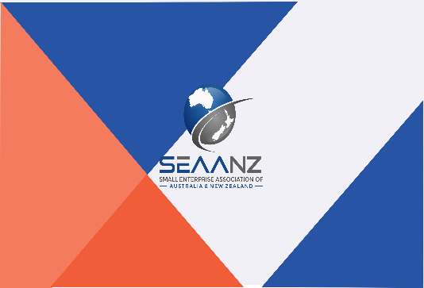
SEAANZ 2021 Online Symposium
SMEs and COVID-19: Just Surviving or Thriving? Sorting Rhetoric from the Realities of COVID-19 for SMEs
Symposium Summary
We are now well over a year down the track from the first cases of COVID-19 being reported; however, we still seem a long way from a COVID-normal world. The pandemic continues to provide unprecedented challenges to businesses and there is no doubt that small to medium enterprises (SMEs) are amongst the hardest hit across the globe. SMEs capture the tension the pandemic has presented leaders around the world with the need to balance economic versus health outcomes. This balancing act is on both supply and demand sides. While SMEs are recognised as major contributors to the nations’ Gross Domestic Product (GDP) and account for over 60 percent of total employment, they are also recognised as the drivers for growth and innovation.
The COVID-19 pandemic continues to cause major disruptions for SMEs, with many facing the stark options of closure, shutdown or transformation. They are options that are being faced within a dynamic environment, where traditional risk management and contingency plans need to be continually updated and the rhetoric of small business innovation and agility is sorely tested. What we are seeing already is that many SMEs and business owner-managers are showing much higher levels of resilience and dynamism than their larger counterparts. While there are many that are ‘doing it tough’ and going out of business, there are also those who are not just surviving but thriving. Our symposium is a chance to explore this diversity and to see not only what we can learn from this incredible sector of the economy, but how we can work with them to help strengthen the recovery effort.
Post-COVID, SMEs’ survival and revitalisation will be key to rebuilding economies across the globe. To achieve this, the rhetoric and realities of COVID-19 and SMEs must be critically examined.
Suggested Topics
We envisage that the proposed online symposium focuses upon strategies to learn from as well as to strengthen SMEs. Symposium/conference proposals may relate to, but not limited to the following topics:
- SMEs and COVID-19
- SMEs workforce
- SMEs Government stimulus packages
- SMEs business transformation
- SMEs and gender
- SMEs resilience
- SMEs workforce
- SMEs digital transitions
- SMEs survival
- SMEs future
Symposium Objectives
- To understand and assess the impact of COVID-19 on SMEs
- To identify the theoretical, practical, social and societal implications of the COVID-19 pandemic on SMEs
- To spotlight resilience and transformation of SMEs amid COVID-19 uncertainty
- To investigate transferable models of contextual relevance for the long-term sustainability of SMEs
Symposium Participants
- Policy makers
- University academics
- Industry practitioners
- Think tanks
- Research students
- Government organisations
Symposium Output
- Enhanced understanding of COVID-19 on SMEs
- Policy conversations and research
- Academic and practice conversations and collaboration
- Publication of symposium abstracts on the SEAANZ website
- Invitation to paper contributors for inclusion of work as chapters in an edited book
Key Dates
- Submission of Extended Abstracts (500 words) by 25th May 2021
- Feedback on Extended Abstracts - 25th June 2021
- Submission of Full Papers (5000 words, including references, tables and figures) – 25th August 2021
- Feedback on Full Papers (peer reviewed double blind) – 25th September 2021
- Online Symposium – 25th October 2021
- Invitation for Book Chapters Due – 25th November 2021
Submissions
Please send your submissions via email to:

Associate Professor Sujana Adapa
Head of UNE Business School
SEAANZ Board Director
University of New England
Armidale 2350 NSW
Australia
Tel: +61 2 67732915
Email: sadapa2@une.edu.au

Symposium Fee
Current SEAANZ members pay 50 AUD to participate and present in the SEAANZ 2021 Online Symposium. Non-SEAANZ members pay 75 AUD to present their work. Three best presentations will receive recognition and will be awarded best symposium presentation certificates as judged by the expert panel. All presenters will receive a certificate of symposium presentation and invited to contribute their work as a book chapter to an edited book.

