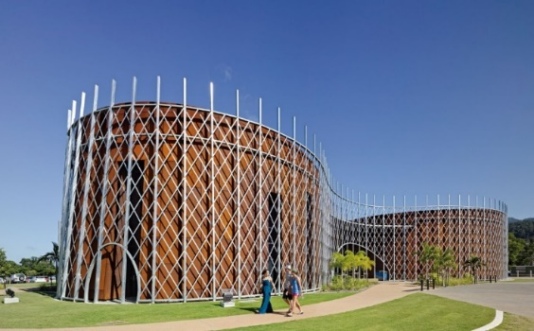
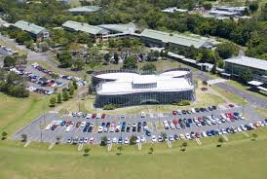

REGISTRATION FORM

2019 ANZAM Doctoral Workshop

Tuesday 3 December 2019 (8:00am – 4:45pm)

Cairns Institute, James Cook University
Smithfield, Cairns. Australia

Supported by

Registration Instructions
- Please complete, sign, and email this registration form to Anne Anderson, Academy Manager, on anzam@anzam.org, no later than Friday 4 October 2019 at 11:59 pm. Your registration will be confirmed ONLY after payment is received. Late registrations will not be accepted.

- Include your written Research Note (3-5 pages excluding references) as a separate document if you intend to present your work at a Roundtable Session.
For more information see the section titled Roundtable Sessions on Page 4.

- The Doctoral Workshop registration fee is AU$95 – this fee is waived for registered three-day delegates of the 2019 ANZAM Conference.

- A separate registration is required for the ANZAM Conference (see http://anzamconference.org/).

Final Check Before Sending
The Registration Form is fully completed | Yes ☐
You have arranged to make payment either via credit card, OR via bank transfer, OR you are already registered for the three days of the 2019 ANZAM Conference. | Yes ☐
If you intend to present your work at a Roundtable Session, your written submission is included as a separate document | Yes ☐

Organisers’ Contact Details
Queries regarding the Roundtable Sessions and Development Seminars
- Dr. Murray Prideaux, James Cook University
murray.prideaux@jcu.edu.au or +61 7 4781 4550

- Paulette Brazzale, ANZAM Doctoral Student Representative
paulette.brazzale@aut.ac.nz or +64 9 921 9065

Queries regarding Registration/Payment
- Anne Anderson, ANZAM Academy Manager:
anzam@anzam.org or +64 3 470 3536

Personal Details
Q1 Please provide your contact details.
Title: Click or tap here to enter text.
First name: Click or tap here to enter text.
Last name: Click or tap here to enter text.
Phone: Click or tap here to enter text.
Email: Click or tap here to enter text.
Q2 Please provide your next of kin contact details (in case of an emergency).
Name of emergency contact: Click or tap here to enter text.
Relationship to you: Click or tap here to enter text.
Phone: Click or tap here to enter text.
Email: Click or tap here to enter text.
Q3 Do you have any special dietary requirements? (e.g. gluten free, nut allergies)
☐ Yes (please specify): Click or tap here to enter text.
☐ No

Affiliation
Q4 Please provide your organisational affiliation(s).
University/Organisation: Click or tap here to enter text.
Department: Click or tap here to enter text.
City/Country: Click or tap here to enter text.
Q5 Are you currently studying at a University?
☐ Yes ☐ No (please specify your occupation): Click or tap here to enter text.
Q6 If you are a student, please indicate your current enrolment status.
☐ Pre-confirmation PhD student ☐ Post-confirmation PhD student
☐ Masters student ☐ Honours student
☐ Other (please specify): Click or tap here to enter text.
Note: Confirmation means that you have been confirmed as a PhD Candidate.

Transport
Q7 Are you likely to need transport to and from the Doctoral Workshop location?
☐ Yes, I would need transport from Central Cairns to the Cairns Institute (approximately 15 kms from Cairns Central.)
☐ No, I will be happy to find my way to and from the Cairns Institute.

Doctoral Workshop Sessions

Roundtable Sessions

The Roundtable Sessions are an opportunity for you to present and discuss your work in an informal setting with other students working in similar areas. You will receive written and verbal feedback from senior academics. To participate, you MUST submit a Research Note (a piece of original, written work) along with your registration to the Workshop by the due date. NO late acceptences. Your submission will be placed in a stream of similar work and circulated in advance to the students and academics who will be at your table.
On the day of the Workshop you will have about 5 minutes to present your work, and then another 10-15 minutes in which to engage in a discussion led by the senior academic(s) at your table. You will receive written feedback either before the Workshop or at the table following the discussion.
The submission guidelines and pre-formatted template document are available online: Research Note Guidelines. During the roundtable discussion, you should be prepared to discuss your work, including:
- What you are researching
- How you plan to conduct the research
- How the research adds to the field
- Why the research is important
If you wish to present and discuss your work at a Roundtable Session, you must submit your work via email to the ANZAM Academy Manager (anzam@anzam.org), along with your completed Registration Form, by Friday 4 October 2019 at 11:59 pm.
Q8 Do you wish to present and discuss your research at a Roundtable Session?
☐ Yes ☐ No (if you answered No, see below)
Concurrent Workshop
There will be a concurrent Workshop, Extracting a slice of your PhD to submit to a conference: Developing an abstract for submission and the makings of a great conference presentation. Please bring a short paragraph (maximum of 150 words) to use in this practical Workshop.
Q9 Do you wish to attend the Workshop on Extracting a slice of your PhD instead of attending a Roundtable Session?
☐ Yes ☐ No

Research Methods Seminars

There will be three concurrent Research Methods Seminars led by senior academics who are experts in the respective seminar topics. The sessions will deal with research methods and address specific topics in each session.

The purpose of the following question is to estimate attendance. On the day of the Doctoral Workshop, you are free to attend any seminar you wish.
Q10 Which seminar are you most likely to attend? Tick only one option (Note: you will not be required to attend the session you pick below.)
Quantitative Methods ☐
Qualitative Methods ☐
Mixed Methods ☐

ANZAM Conference Registration
Q11 Have you already registered for the 2019 ANZAM Conference?
☐ Yes
☐ No
Note: Full (three-day) Conference Registration includes free attendance at the Doctoral Workshop – you will not need to pay again, but you must register separately for both.

Terms and Conditions
Please note the following terms and conditions for the Doctoral Workshop.
1. The program is subject to change without notice.
2. Late registrations will not be accepted.
3. Registration is confirmed once payment is received.
4. The Workshop fee is waived for registered three-day 2019 ANZAM Conference delegates.
5. Please contact us as soon as possible if you are unable to attend.
6. By registering you agree to abide by the rules and policies of ANZAM.
7. Photos will be taken during the event for ANZAM promotional purposes.
8. ANZAM gives no guarantee as to the quality or otherwise of third-party services.

Payment
Credit Card - ☐ Yes ☐ No
Please complete, sign, and email this registration form to Anne Anderson, Academy Manager, on anzam@anzam.org

Credit Card Authority: ☐ Visa
☐ Other (please specify): Click or tap here to enter text.
Card Holders Name: Click or tap here to enter text.
Card Number: Click or tap here to enter text.
Expiry Date Click or tap here to enter text.
Amount: AU$95
Signed: _____________________________

Do you require a receipt to be sent to your listed email address
☐ Yes ☐ No

Bank Transfer - ☐ Yes ☐ No
If paying by bank transfer, ensure you include your name as the reference so we can identify your payment:
Account Name Australian and New Zealand Academy of Management Limited
Bank National Australia Bank
BSB 084-004
Account Number 18131-5617
Address Southport Branch
27 Scarborough Street
SOUTHPORT QLD 4215 AUSTRALIA
SWIFT Code NATAAU3303M (only for transfers from outside Australia)

Do you require a receipt to be sent to your listed email address
☐ Yes ☐ No

