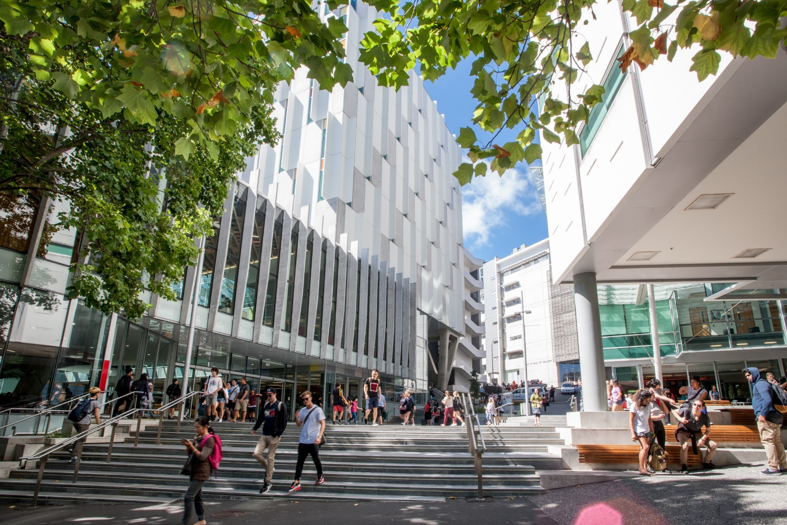

2018

REGISTRATION FORM

ANZAM Doctoral Workshop

Tuesday 4 December 2018 (8.00am – 5.00pm)

Auckland University of Technology
Auckland, New Zealand

Registration Instructions
- Please complete, and then email this registration form to Anne Anderson, Academy Manager, by no later than Monday 1 October 2018 at 11:59pm. Your registration will be confirmed once payment is received or full student registration for ANZAM 2018 is confirmed. Late registrations will not be accepted.
Email registrations to: anzam@anzam.org
- Include written submissions for the Roundtable Session as a separate document. For more information see the section titled Roundtable Sessions on Page 3.
- The Doctoral Workshop registration fee is AU$95 –this fee is waived for registered three-day delegates of the 2018 ANZAM Conference. Separate registration is required for the ANZAM Conference (see http://anzamconference.org/ ).

Final Check Before Sending
The entire Registration Form is fully completed | Yes ☐
You have arranged to make payment either via credit card, OR via bank transfer, OR you are already registered for the three-days of the 2018 ANZAM Conference | Yes ☐
If you intend to present your work at a Roundtable Session, your written submission is included as a separate document | Yes ☐

Organisers’ Contact Details
Queries regarding the Roundtable Sessions and Seminars
- Paulette Brazzale, ANZAM Doctoral Student Representative
Paulette.Brazzale@aut.ac.nz or +64 9 921 9065
- Edward Hyatt, ANZAM Doctoral Student Representative:
hyatte@unimelb.edu.au or +61 3 9035 5186
Queries regarding Registration/Payment
- Anne Anderson, ANZAM Academy Manager:
anzam@anzam.org or +64 3 470 3536

Personal Details
Q1 Please provide your contact details.
Title: Click or tap here to enter text.
First name: Click or tap here to enter text.
Last name: Click or tap here to enter text.
Phone: Click or tap here to enter text.
Email: Click or tap here to enter text.
Q2 Please provide your next of kin contact details (in case of an emergency).
Name of emergency contact: Click or tap here to enter text.
Relationship to you: Click or tap here to enter text.
Phone: Click or tap here to enter text.
Email: Click or tap here to enter text.
Q3 Do you have any special dietary requirements? (e.g. gluten free, nut allergies)
☐ Yes (please specify): Click or tap here to enter text.
☐No

Affiliation
Q4 Please provide your organisational affiliation(s).
University/Organisation: Click or tap here to enter text.
Department: Click or tap here to enter text.
City/Country: Click or tap here to enter text.
Q5 Are you currently studying at a University?
☐ Yes
Q6 If you are a student, please indicate your current enrolment status.
☐ Pre-confirmation PhD student ☐ Post-confirmation PhD student
☐ Masters student ☐ Honours student
☐ Other (please specify): Click or tap here to enter text.
Note: Confirmation means that you have been confirmed as a PhD Candidate.

Doctoral Workshop Sessions

Roundtable Sessions
The Roundtable Sessions are an opportunity for you to present and discuss your work in an informal setting with other students working in similar areas. You will receive expert written and verbal feedback from senior academics. In order to participate you will need to submit a piece of original, written work as a research note along with your registration to the Workshop. Your research note will be placed with other similar work and will be circulated in advance to the students and academics who will be in your group. On the day of the Workshop you will have about 5 minutes to present your work, and then another 10-15 minutes in which to engage in a discussion led by the senior academic(s) at your table. You will receive written feedback either before the Workshop or at the table following the discussion.
The submission guidelines and pre-formatted template document are available online: Roundtable Research Note Guidelines . During the Roundtable discussion you should be prepared to discuss your work, including:
- What you are researching
- How you plan to conduct the research
- How the research adds to the field
- Why the research is important
If you wish to present and discuss your work at a Roundtable Session, you must submit your work via email to the ANZAM Academy Manager (anzam@anzam.org), along with your completed Registration Form, by Monday 1 October 2018 at 11:59pm.

Q7 Do you wish to present and discuss your research at a Roundtable Session?
☐ Yes ☐ No
If you answered NO to Q7
There will be a concurrent Workshop, “Extracting a slice of your PhD to submit to a conference: Developing an abstract for submission and the makings of a great conference presentation”. For this session you will be asked to bring a short paragraph (max 150 words) to use in this practical Workshop.
Q8 Do you wish to attend the Workshop on “Extracting a slice of your PhD” instead of attending a Roundtable Session?
☐ Yes ☐ No

Research Methods Seminars
There will be three concurrent Research Methods Seminars led by senior academics.
The purpose of the following question is to estimate attendance. On the day of the Doctoral Workshop, you are free to attend any Seminar you wish and you will not be required to attend the session(s) you pick below.
Q9 Which Seminar do you think you are most likely to attend?
Quantitative Methods ☐
Qualitative Methods ☐
Mixed Methods ☐

Editors’ Panel - The nuts and bolts of academic publishing
A panel of experienced editors will discuss the fundamentals of getting published. We will address “which journal and why?”, “what makes an editor recommend acceptance?”, and “the transition from PhD writing to journal article writing”. If you have a question you would like our editors to address please let us know below.
Q10 Question for the Editors’ Panel on academic publishing (optional):
Click or tap here to enter a question for the editors

ANZAM Conference Registration
Q11 Have you already registered for the 2018 ANZAM Conference?
☐ Yes ☐ No
Note: Full (three-day) Conference Registration includes free attendance at the Doctoral Workshop – you will not need to pay again, but you must register separately.

Terms and Conditions
Please note the following terms and conditions for the Doctoral Workshop.
1. The program is subject to change without notice.
2. Late registrations will not be accepted.
3. Registration is confirmed once payment is received.
4. Workshop fee is waived for registered three-day 2018 ANZAM Conference delegates.
5. Please contact us as soon as possible if you are unable to attend.
6. By registering you agree to abide by the rules and policies of ANZAM.
7. Photos will be taken during the event for ANZAM promotional purposes.
8. ANZAM gives no guarantee as to the quality or otherwise of third-party services.
Payment
Credit Card – Yes ☐ No☐
Please print, sign, scan, and then send this page to the Academy Manager via email:
Email anzam@anzam.org
Credit Card Authority: ☐ Visa
☐ Other (please specify):
Card Holders Name: Click or tap here to enter text.
Card Number: __ __ __ __ / __ __ __ __ / __ ____ __ / __ __ __ __
Expiry Date: __ __ / __ __
Amount: AU$95
Signed: _____________________________
Do you require a receipt for your credit card payment?
☐ Yes (a receipt will be emailed to your listed email address) ☐ No

Bank Transfer - Yes ☐ No☐
If paying by bank transfer, you will need the following details, include your name as the reference so we can identify your payment.
Account Name Australian and New Zealand Academy of Management Limited
Bank National Australia Bank
BSB 084-004
Account Number 18131-5617
Address Southport Branch
27 Scarborough Street
SOUTHPORT QLD 4215 AUSTRALIA
SWIFT Code NATAAU3303M (only for transfers from outside Australia)
Do you require a receipt for your bank transfer payment?
☐ Yes (a receipt will be emailed to your listed email address) ☐ No

