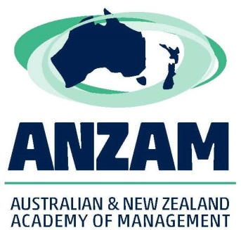
ANZAM PELT Grants - 2018
Promoting Excellence in Learning & Teaching
Funding for projects with budgets up to $5000

Grant Aims

The purpose of the ANZAM PELT Grant is to provide funding support for new projects that will aid the development of management teaching in Australia and New Zealand. Ideally a PELT Grant will result in new resources/processes/understandings, etc, that will benefit the broader community of management teachers, rather than just one subject or a single program within one university. Expected outcomes would typically include (but are not limited to) at least one new teaching resource, which would be placed on the ANZAM website to be available to all members.

Your application (2 pages maximum) should include the following information:

Project Investigators

All named Chief Investigators must be ANZAM members for the year the project runs, i.e., 2019. You may have Partner Investigators who are not current ANZAM members but the Grant will not be in their name. Please include the following details for each Chief Investigator:

- Name
- University
- Position/Level

Aim/s of the Project (100 words maximum)

This section should clearly outline what you intend to achieve with this project.

Approach (200 words maximum)

This section should include a brief description of the methods and activities that will be used, what classes and types of students will be involved, etc.

Anticipated Outcomes (100 words maximum)

Priority will be given to Grants that show clear teaching and learning outcomes in relation to management education in Australia and New Zealand. Projects that are class or university specific should be funded by local sources.

Anticipated Budget

All budget items to be funded by the Grant need to be specified. Where final figures are not known, estimates can be provided and justified. Budget items can include, but are not limited to: research assistance, travel (directly related to conducting the project - not conference travel), required software/hardware, teaching assistance, support for the development of teaching materials, learning design support etc. ANZAM will not fund budget items that would normally be covered by the investigators’ host university (e.g., standard computer equipment, teaching staff, printing, photocopying, telephone calls).

Project Timeline

The project needs to be completed by 30 November 2019 with the new teaching resource to be available on the ANZAM website by the ANZAM 2019 Conference. Recipients are also invited to present their winning project at the ANZAM 2019 Conference.

PELT Grant Criteria

- Utility of outcomes and developed knowledge for management education professionals
- Value for money
- Project feasibility

Submitting your Application

Please submit your written proposal by 5.00pm, Friday 7 September 2018 to anzam@anzam.org.

The selection panel’s decision of successful awardees will be final; no correspondence about decisions will be entered into.

The selection panel further reserves the right not to award a Grant if the quality of the application/s is not deemed sufficiently high.

The winner will be announced at the ANZAM Conference in Auckland, 4-7 December 20187

For further information, contact Dr Judy Matthews:
jh.matthews@qut.edu.au
(Acting Chair, ANZAM Education Committee) or visit http://www.anzam.org/about/awards/excellence/

