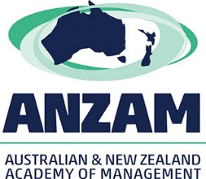

2017 ANZAM Registration Form

ANZAM Doctoral Workshop
Tuesday 5 December 2017 (8:00am – 4:30pm)
Social Event (4:30PM to 5:30PM)
The University of Melbourne
Melbourne, Australia

Supported by

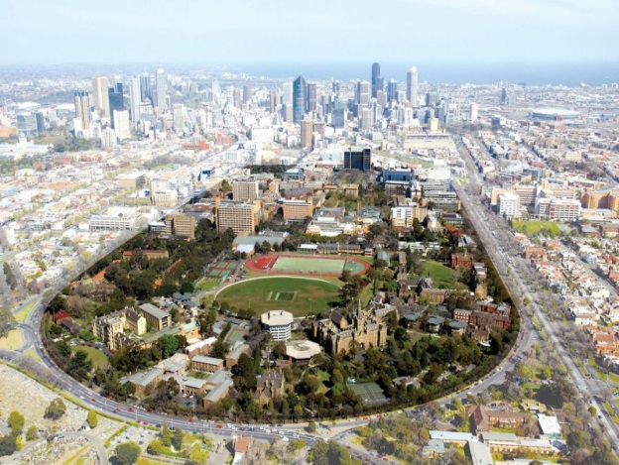
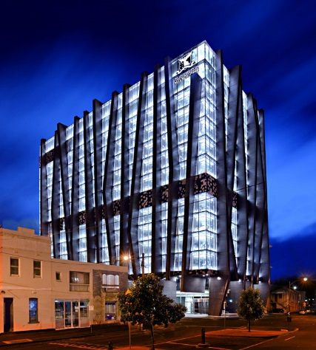

Contents Page

Instructions 1

Personal Details 2

Affiliation 2

Dietary Needs 2

Enrolment Status 3

Doctoral Sessions 3-4

Roundtable Sessions 3

Development Seminars 4

Social Function 4

ANZAM Conference Registration 5

Terms and Conditions 5

Payment by Credit Card 5

Payment by Bank Transfer 6

Final Check before Sending 6

Organisers’ Contact Details 6

Instructions
- Please complete, sign, and then email or fax this registration form to Anne Anderson, Academy Manager, by no later than Sunday 1 October 2017 at 11:59pm.
Email anzam@griffith.edu.au | Fax +61 7 555 27798
Your registration will be confirmed once payment is received or your three-day ANZAM Conference registration is confirmed. Late registrations will not be accepted.
- Please be sure to include any written submission (3-5 pages excl. references) as a separate document if you intend to present your work at a Roundtable Session.
For more information see the section titled Roundtable Sessions on Page 3.
- The Doctoral Workshop registration fee is AU$95; this fee is waived for registered three-day delegates of the 2017 ANZAM Conference, however you must register separately. See http://anzamconference.org/attending/registrations/

Personal Details
Q1 Please provide your contact details (required for WiFi access, please write clearly).
Title: ________________________
First name: ________________________________________________
Last name: ________________________________________________
Phone: _______________________________________
Email: _______________________________________

Q2 Please provide your next of kin contact details (in case of an emergency).
Name of emergency contact: ______________________________________
Relationship to you: __________________________________________
Phone: _______________________________________
Email: _______________________________________

Affiliation
Q3 Please provide your organisational affiliation(s).
University/Organisation: ______________________________________
Department: ______________________________________________
City/Country: ______________________________________________

Dietary Needs
Q4 Do you have any special dietary restrictions? (e.g. gluten free, nut allergies)
☐ Yes (please specify): ____________________________________
☐ No

Enrolment Status
Q5 Are you currently studying at a University?
☐ Yes ☐ No (please specify your occupation): __________________

Q6 If you are a student, please indicate your current enrolment status.
☐ Pre-confirmation PhD student ☐ Post-confirmation PhD student
☐ Masters student ☐ Honours student
□ Other (please specify): ___________________________
Note: Confirmation means that you have been confirmed as a PhD Candidate.

Roundtable Sessions
The Roundtable Sessions are an opportunity for you to present and discuss your work in an informal setting with other students working in similar areas. You will receive expert written and verbal feedback from senior academics as well. In order to participate you will need to submit a piece of original, written work along with your registration to the Workshop. Your submission will be placed in a stream of similar work and it will be circulated in advance to the students and academics who will be at your table. On the day of the Workshop you will have about 5 minutes to present your work, and then another 10-15 minutes in which to engage in a discussion led by the senior academic(s) at your table. You will receive written feedback either before the Workshop day or at the table following the discussion.
The submission guidelines and pre-formatted template document are available online: Roundtable Submission Guidelines. During the roundtable discussion you should be prepared to discuss your work, including:
- What you are researching
- How you plan to conduct the research
- How the research adds to the field
- Why the research is important
If you wish to present and discuss your work at a Roundtable Session, you must submit your work via email to the ANZAM Academy Manager (anzam@griffith.edu.au), along with your completed Registration Form, by Sunday 1 October 2017 at 11:59pm.
Q7 Do you wish to present and discuss your research at a Roundtable Session?
☐ Yes ☐ No

Development Seminars
There will be two sets of concurrent development seminars led by senior academics who are experts in the respective seminar topics. Three of the sessions will deal with research methods and address specific topics in each session. The other three sessions will deal with topics related to general professional development; these topics will be repeated.

Participants will have a choice to attend one of six seminars in each session. The purpose of the following two questions is to estimate attendance. On the day of the Doctoral Workshop, you are free to attend any seminar you wish and you will not be required to attend the session(s) you pick below.

Q8 Session 1: Which seminar do you think you are most likely to attend? Tick only one option.
Quantitative Methods – Secondary Data ☐
Qualitative Methods – Interview Techniques ☐
Mixed Methods ☐
How to Review Papers ☐
How to Complete an R&R ☐
Systematic Literature Review ☐

Q9 Session 2: Which seminar do you think you are most likely to attend? Tick only one option.
Quantitative Methods – Survey Design ☐
Qualitative Methods – Thematic Analysis ☐
Mixed Methods ☐
How to Review Papers ☐
How to Complete an R&R ☐
Systematic Literature Review ☐

Social Function
A request for RSVPs to the Social Function will be circulated closer to the date.
NOTE: If you are registered for the 2017 ANZAM Conference, you will have time to also attend the Welcome Reception, to be held from 6:00pm – 8:00pm at the nearby State Library of Victoria.

ANZAM Conference Registration
Q10 Have you already registered for the 2017 ANZAM Conference?
☐ Yes ☐ No
Note: Full three-day ANZAM Conference Registration includes free attendance at the Doctoral Workshop – you will not need to pay again, but you must register separately.

Terms and Conditions
Please note the following terms and conditions for the Doctoral Workshop.
1. The program is subject to change without notice.
2. Late registrations will not be accepted.
3. Registration is confirmed once payment is received.
4. The Workshop fee is waived for registered three-day 2017 ANZAM Conference delegates.
5. Please contact us as soon as possible if you are unable to attend.
6. By registering you agree to abide by the rules and policies of ANZAM.
7. Photos will be taken during the event for ANZAM promotional purposes.
8. ANZAM gives no guarantee as to the quality or otherwise of third-party services.

Payment By Credit Card
Please print, sign, and then send this page to the Academy Manager via email or fax:
Email anzam@griffith.edu.au | Fax +61 7 555 27798
Credit Card Authority: ☐ Visa
☐ Other (please specify): _______________
Card Holders Name: ___________________________________________
Card Number: __ __ __ __ / __ __ __ __ / __ __ __ __ / __ __ __ __
Expiry Date: __ __ / __ __
Amount: AU$95
Signed: _____________________________
Q11 Do you require a receipt for your credit card payment?
☐ Yes (a receipt will be emailed to your listed email address) ☐ No

Payment By Bank Transfer
If paying by bank transfer, you will need the following details (include your name as the reference so we can identify your payment:
Account Name Australian and New Zealand Academy of Management Limited
Bank National Australia Bank
BSB 084-004
Account Number 18131-5617
Address Southport Branch
27 Scarborough Street
SOUTHPORT QLD 4215 AUSTRALIA
SWIFT Code NATAAU3303M (only for transfers from outside Australia)
Q12 Do you require a receipt for your bank transfer payment?
☐ Yes (a receipt will be emailed to your listed email address) ☐ No

Final Check before Sending
The entire Registration Form is fully completed in legible writing (questions 1-10 are required) | Yes ☐
You have arranged to make payment either via credit card, OR via bank transfer, OR you are already registered for the full three days of the 2017 ANZAM conference | Yes ☐
If you intend to present your work at a Roundtable Session, your written submission is included as a separate document | Yes ☐

Organisers’ Contact Details
Queries regarding the Roundtable Sessions and Development Seminars
- Edward Hyatt, ANZAM Doctoral Student Representative:
hyatte@unimelb.edu.au or +61 3 9035 5186
- Monique Shears, Support Officer (Research & Engagement)
research-mgmt-mktg@unimelb.edu.au
- Hieu Nguyen, ANZAM Doctoral Student Representative
h.nguyen1@uq.edu.au or +61 7 3346 8100

Queries regarding Registration/Payment
- Anne Anderson, ANZAM Academy Manager:
anzam@griffith.edu.au or +61 7 5552 7792

