ANZAM 2016 Registration Form

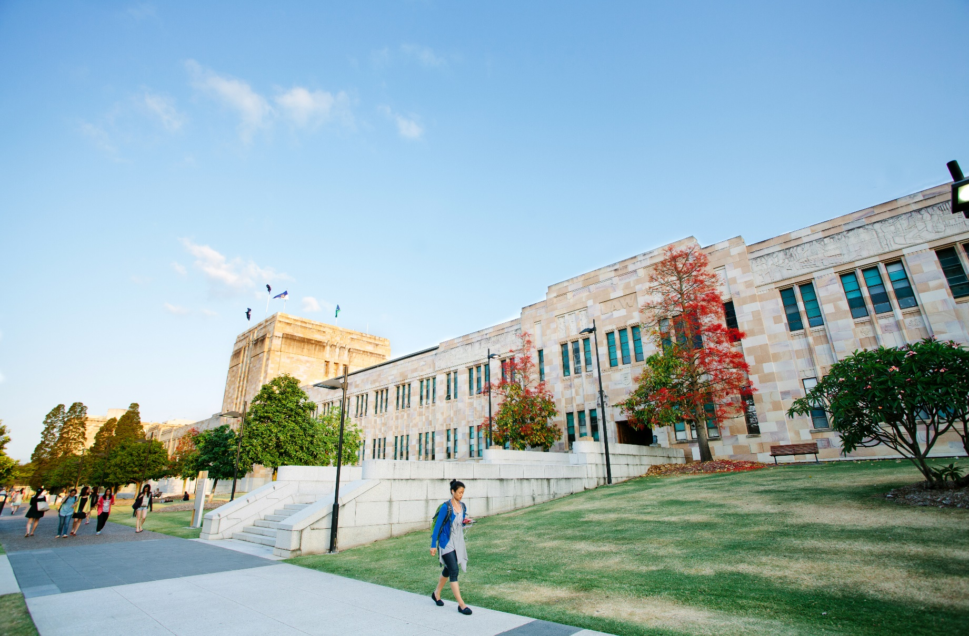

ANZAM Year-End Doctoral Workshop
Tuesday 6 December 2016 (8:00am – 4.30pm)
The University of Queensland, Brisbane, Australia

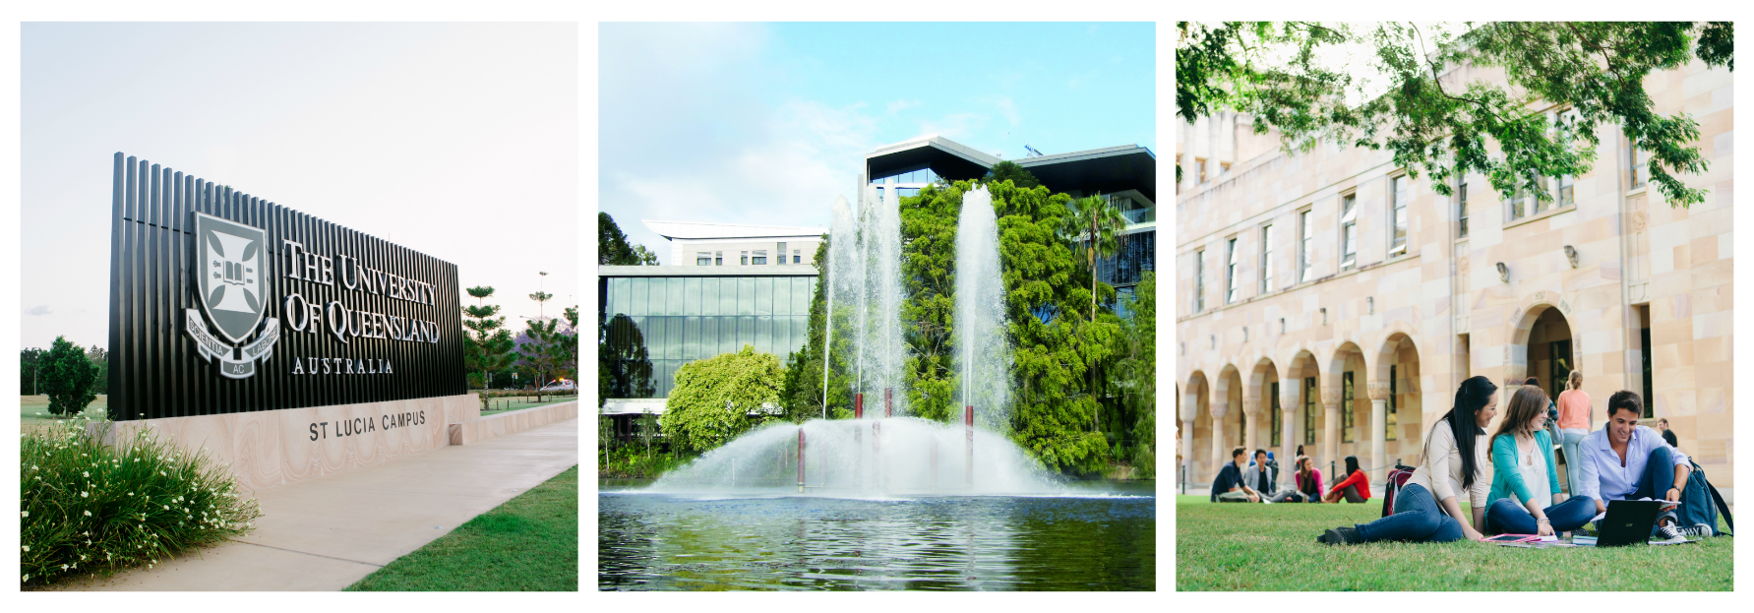

Contents Page

Instructions 2

Personal Details 3

Affiliation 3

Dietary Needs 3

Enrolment Status 4

Doctoral Sessions 4

Roundtable Discussions Session 5

Pitch Presentations Session 5

Social Function 5

ANZAM Conference Registration 6

Terms and Conditions 6

Payment by Credit Card 6

Payment by Bank Transfer 7

Final Check before Sending 7

Organisers’ Contact Details 7

Instructions
- Please complete, sign, and then email or fax this registration form to Anne Anderson, Academy Manager, by no later than Friday 7 October 2016.
Email anzam@griffith.edu.au | Fax +61 7 555 27798
Your registration will be confirmed once payment is received. Late registrations will not be accepted.
- Please be sure to include your written submission (3-5 pages excl. references) and/or pitch template as a separate document if you intend to present your work at a roundtable discussion/pitch session – see the submission guidelines on Page 4.
- The Doctoral Workshop registration fee is AU$95 – note that this fee is waived for registered delegates of the ANZAM Conference. Separate registration is required for the ANZAM Conference (see http://anzam2016.com/registration/).

Personal Details
Q1 Please provide your contact details (required for WiFi access, please write clearly).
Title: ________________________
First name: ________________________________________________
Last name: ________________________________________________
Phone: _______________________________________
Email: _______________________________________

Q2 Please provide your next of kin contact details (in case of an emergency).
Name of next of kin: __________________________________________
Relationship to you: __________________________________________
Phone: _______________________________________
Email: _______________________________________

Affiliation
Q3 Please provide your organisational affiliation(s).
University/Organisation: ______________________________________
Department: ______________________________________________
City/Country: ______________________________________________

Dietary Needs
Q4 Do you have any special dietary needs? (e.g., vegetarian, gluten free)
☐ Yes (please specify): ____________________________________
☐ No

Enrolment Status
Q5 Are you currently studying at a University?
☐ Yes ☐ No (please specify your occupation): __________________
Q6 If you are a student, please indicate your current enrolment status.
☐ Pre-confirmation PhD student ☐ Post-confirmation PhD student
☐ Masters student ☐ Honours student
□ Other (please specify): ___________________________
Note: Confirmation means that you have been confirmed as a PhD Candidate.

Doctoral Sessions
There are two types of sessions at the ANZAM doctoral workshop: 1) Roundtable Discussion Sessions, and 2) Pitch Presentations. Prizes will be awarded for the best submissions in the two sessions, with the former being sponsored by ANZAM and the latter by the UQ Business School. To enter either (or both) sessions, you must send your respective submission(s) via email to the ANZAM Academy Manager (anzam@griffith.edu.au) along with your completed Registration Form by 7 October 2016.
Roundtable Discussion Sessions | Pitch Presentations
The Roundtable sessions are an opportunity to present your work in a roundtable setting. You will also gain feedback from other students working in similar areas and several senior academics. Please note that you will need to include with this application a separate written submission to apply and this will be circulated to both the students and academics at your table in advance. On the day you will have about 5 minutes to orally present your work, and then 15 minutes to engage in a discussion that will be led by the academic chair/co-chair at your table. | The Pitch presentations allow you to “pitch” and present your research proposal to the doctoral workshop attendees including senior academics. To enter the Pitch competition, you will need to complete a prescribed 2-page template that provides a simple, methodical tool to confidently and succinctly “pitch” essential elements of a new research proposal to an academic expert. The Pitch enhances the success of your research proposal from its early stages. For more explanations of the pitching template and its use, please see Faff (2015)’s SSRN paper on “Pitching Research”
Submission Guidelines (7 October 2016 Deadline)
If you wish to present your work at a Roundtable Session you must include a written submission with this application. The submission guidelines and pre-formatted template document can be found at: Roundtable Submission Guidelines | To present your Research Pitch you must complete and submit a 2-page template related to your thesis research with this application. The submission guidelines and pre-formatted template document can be found at:  Pitch Submission Guidelines

Roundtable Discussion Session
Q7 Do you wish to discuss your research at a Roundtable Discussion Session?
☐ Yes (please see the guidelines on Page 4) ☐ No
Q8 Do you wish to be considered for the Most Promising Paper Award?
☐ Yes ☐ No
Note: On the day of the workshop you will have around 5 minutes to present your work, and then another 10-15 minutes to engage in a discussion lead by the academic chair/co-chair at your table. No PowerPoint slides or additional hand-outs are permitted. Everyone at your table will have already read your written submission, so the purpose of your oral presentation is to remind them and to very briefly highlight the key points. At the end you may, if you wish, direct feedback toward a particular area of your work that you would like input on.
You should cover: - What you are researching
- How you plan to investigate
- How it adds to the field
- Why it is important

Pitch Presentation Session
Q9 Do you wish to enter into the Pitch Presentation Session?
☐ Yes (please see the guidelines on Page 4) ☐ No
Note: By submitting your pitch, you will be entering into the “Pitch Competition”. The best two pitches from the submission pool will be selected by a committee set up for this purpose. The winners will present their pitches (for about 15 minutes each) at the final plenary session of the Doctoral Workshop. PowerPoint slides are permitted and encouraged. Prizes will be awarded to the two winners afterwards.

Social Function
Q10 Will you be attending the Workshop Social Function at 4:30pm–6:00pm on Monday 5 December 2016? (Gibson Room, Level 10, Z Block, QUT Gardens Point)
☐ Yes ☐ No

ANZAM Conference Registration
Q11 Have you already registered for the main 2016 ANZAM Conference?
☐ Yes ☐ No
Note: Full Conference Registration includes free attendance at the Doctoral Workshop – you will not need to pay again, but you must register separately.

Terms and Conditions
Please note the following terms and conditions for the Doctoral Workshop.
1. The program is subject to change without notice.
2. Late registrations will not be accepted.
3. Registration is confirmed once payment is received.
4. The Workshop fee is waived for registered ANZAM Conference delegates.
5. Please contact us as soon as possible if you are unable to attend.
6. By registering you agree to abide by the rules and policies of ANZAM.
7. Photos will be taken during the event for ANZAM promotional purposes.
8. ANZAM gives no guarantee as to the quality or otherwise of third-party services.

Payment By Credit Card
Please print, sign, and then send this page to the Academy Manager via email or fax:
Email anzam@griffith.edu.au | Fax +61 7 555 27798
Credit Card Authority: ☐ Visa
☐ Other (please specify): _______________
Card Holders Name: ___________________________________________
Card Number: __ __ __ __ / __ __ __ __ / __ __ __ __ / __ __ __ __
Expiry Date: __ __ / __ __
Amount: AU$95
Signed: _____________________________
Q12 Do you require a receipt for your credit card payment?
☐ Yes (a receipt will be emailed to your listed email address) ☐ No

Payment By Bank Transfer
If paying by bank transfer, you will need the following details (include your name as the reference so we can identify your payment:
Account Name Australian and New Zealand Academy of Management Limited
Bank National Australia Bank
BSB 084-004
Account Number 18131-5617
Address Southport Branch
27 Scarborough Street
SOUTHPORT QLD 4215 AUSTRALIA
SWIFT Code NATAAU3303M (only for transfers from outside Australia)
Q13 Do you require a receipt for your bank transfer payment?
☐ Yes (a receipt will be emailed to your listed email address) ☐ No

Final Check Before Sending
The entire Registration Form is fully completed in legible writing (questions 1-11 are required) | Yes ☐
You have arranged to make payment either via credit card, OR via bank transfer, OR you are already registered for the ANZAM 2016 conference | Yes ☐
If you intend to present your work at a Roundtable Discussion Session, your written submission is included as a separate document | Yes ☐
If you intend to present your work at the Pitch Presentation, your 2-page completed pitch template is included as a separate document | Yes ☐

Organisers’ Contact Details
Queries regarding the Program, Roundtable Sessions, and Pitch Presentations
- Hieu Nguyen, ANZAM Doctoral Student Representative:
h.nguyen1@uq.edu.au or +61 7 3346 8100
- Andrei Lux, ANZAM Doctoral Student Representative:
andrei.lux@otago.ac.nz or +64 3 479 8133
- Associate Professor Remi Ayoko, UQBS Doctoral Workshop Co-ordinator: R.Ayoko@business.uq.edu.au or +61 7 3346 8145)

Queries regarding Registration/Payment
- Anne Anderson, ANZAM Academy Manager:
anzam@griffith.edu.au or +61 7 5552 7792

